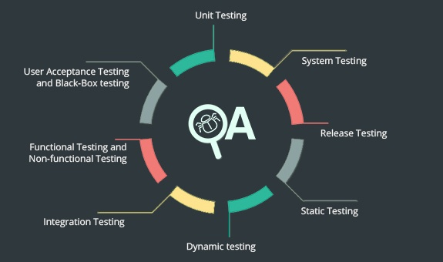

**CSE427 Project 1 Proposal**

Unit Testing on Email Pattern & Shared Preferences Validation in Android

|  |  |
| --- | --- |
| NAME | ID |
| M. Arabi Hasan Sakib | 1030165042 |
| Md Mantasarul Elahi | 1512518042 |

Topic

For Project-1 we are going to work with a form segment of an Android based application. A fragment of a big application (User information setting part) would be tested. User would be able to provide with their name, date of birth and valid email address. Pressing the save button would check validity of each individual input before saving. The information can be reverted as well. Though the scope could be big, in this phase we will be analyzing and writing test cases on EmailValidator and SharedPreferencesHelper java classes only.

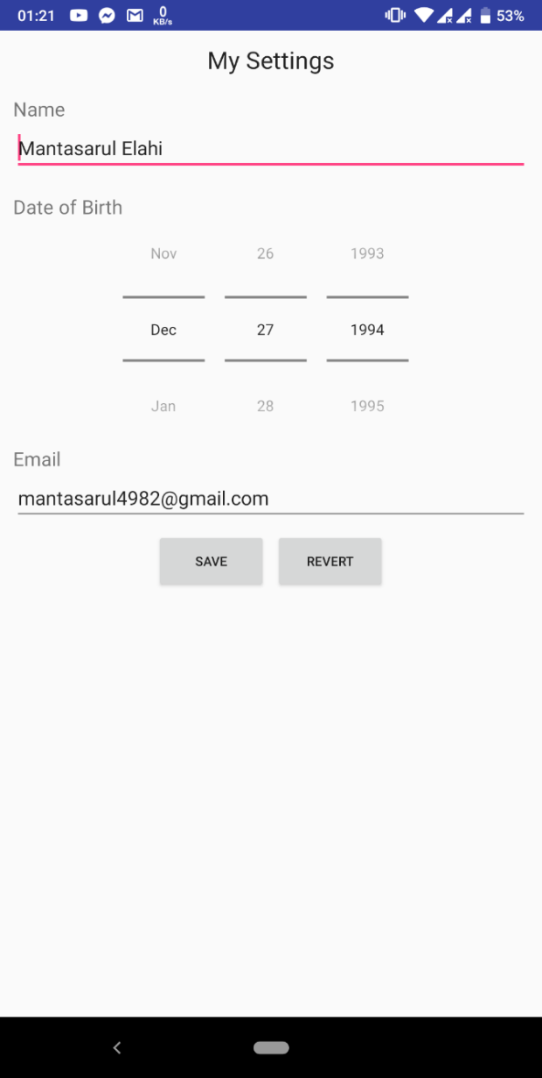

Objectives

* Write unit test cases on the email and shared preferences class.
* Implementation of unit testing of individual Java Methods.
* Developing test classes covering as many test case scenarios as possible.
* Detections of exceptions.
* Module Testing.
* Identification of possible existing bugs after unit testing.